TEXTILE MATERIALS PROCESSING

ED

Textile fibres are fine structures similar to human hair; they are either long or short.

Long fibres are called Filament Fibres, they are found in synthetic fibres with the exception of linen and silk, and they give a smooth feel and finish to fabrics.

Short fibres are called Staple fibres they are found mostly cotton and wool; they have a tendency to be “hairier” than filament fibres. Staple fibres are spun tightly when forming them into a yarn.

Materials are made in three stages:
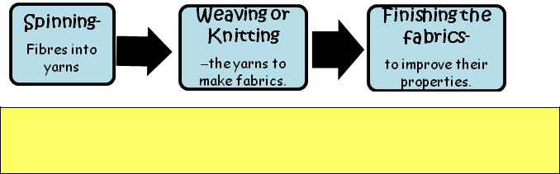

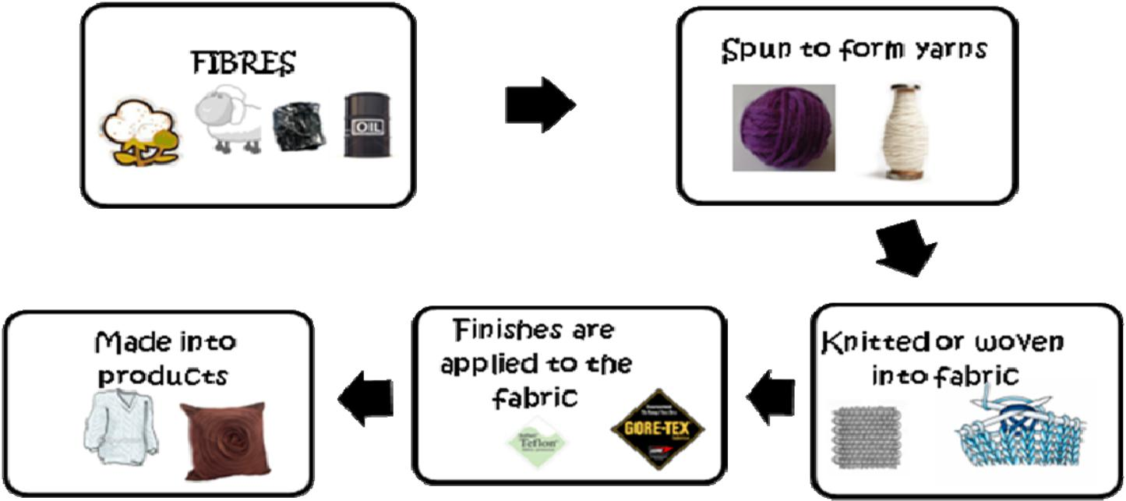
The diagram below shows the various processes that the fibres go through when developing them indo fabrics.

